**Lab 6 Report**

ADITYA DESHPANDE,

TEJ KIRAN MEKA,

MAHESH VEMULA,

JAGADEESH. P. D. RAO

For this lab we have used Snake game that uses both sensor tag and touch to change directions of snake in the game.

Below screenshot represents the start page of the game.

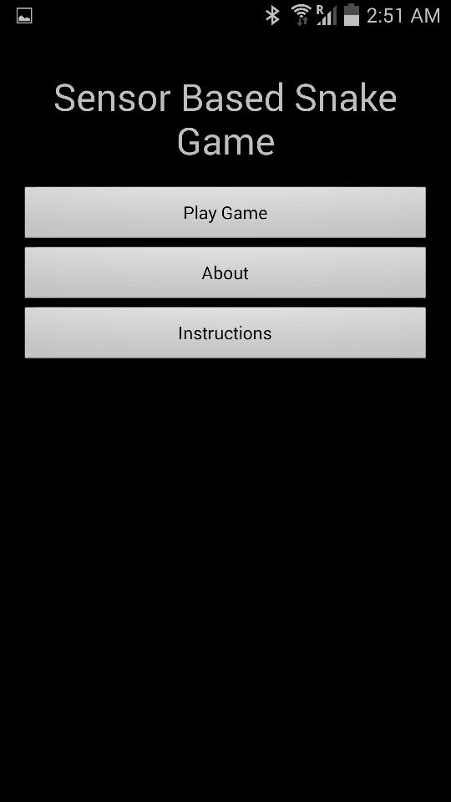

Below screen shot represents the instructions that user need to follow before starting the game.

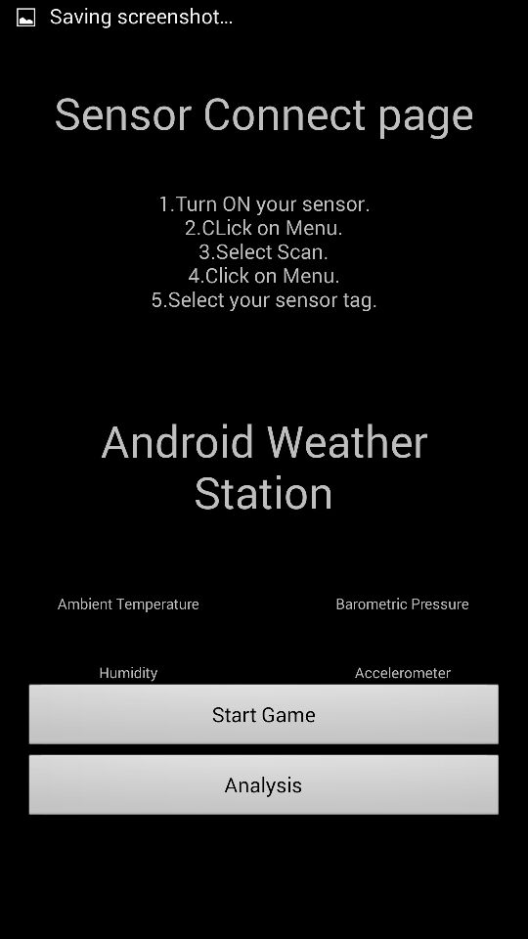

Below screenshot represents the game play using sensor tag.

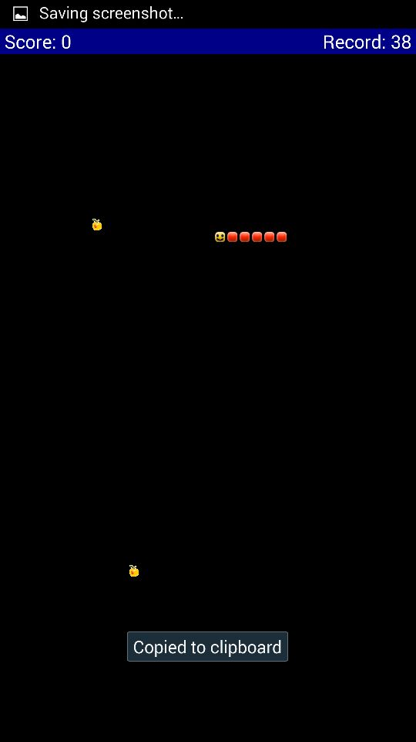

Below screenshot represents activity analysis of the game played by the user. We plotted the chart based on number of gestures made by the user.

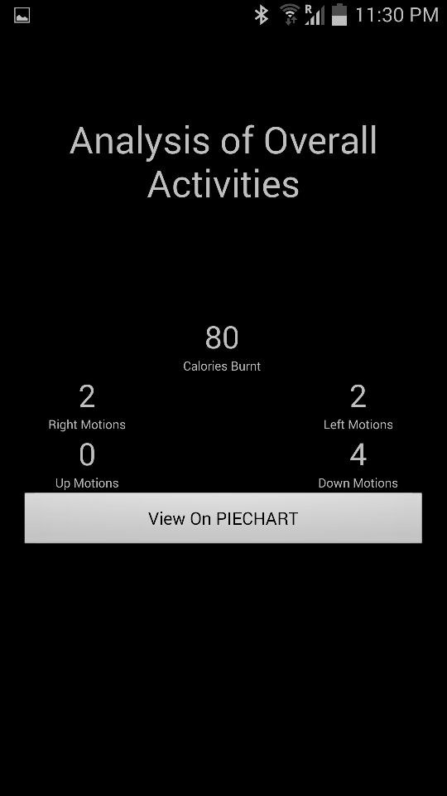

Below screenshot represents the number of different gestures plotted on pie chart. When the sector is touched it displays the name of respective gesture.

